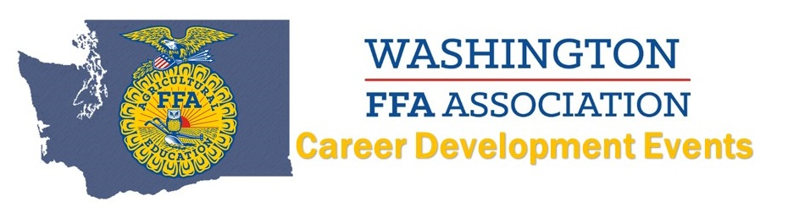
2016 Dairy Cattle Evaluation
Coordinator: Curt DeHaan
Top 10 INDIVIDUALS
(Name AND Chapter):
10. George Dejony, Lynden Christian
9. Riley Lagerway, Nooksack Valley
8. Emily Parson, Nooksack Valley
7. Kortney Bailey, Elma
6. Luuk Venning, Lynden Christian
5. Eric Steiger, Lynden Christian
4. Luke Wolfisberg, Lynden
3. Mickey Velasco, Elma
2. Dave Downing, Elma
1. Emily Rockey, Elma
Top 8 TEAMS:
8. --
7. --
6. --
5.
4.
3.
2.
1.

