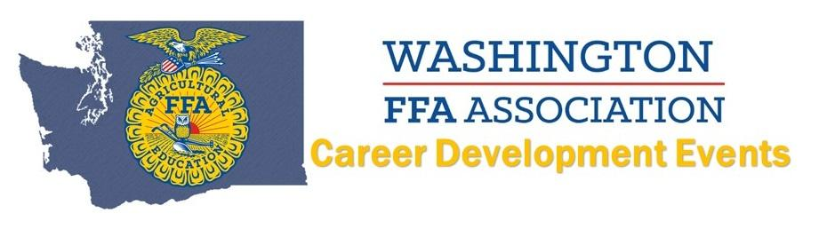
2021 Milk Quality & Products Evaluation CDE
Top 10 INDIVIDUALS
(Name AND Chapter):
10. Zoe Galbreath, Lind-Ritzville
9. Colten Cuperus, Nooksack Valley
8. Addy Colbert, Lind-Ritzville
7. Isabel Fadenrecht, Cashmere
6. Payten Heyen, Cashmere
5. Riley Johnson, Cashmere
4. Jenna Whitaker, Moses Lake
3. Gabriell Levine, Nooksack Valley
2. Mac Kelly, Cashmere
1. Tristan Hoffman, Cashmere
Top 8 TEAMS:
8. Mount Baker
7. Granite Falls
6. Mount Vernon Christian
5. Toledo
4. Nooksack Valley
3. Lind-Ritzville
2. Moses Lake
1. Cashmere

